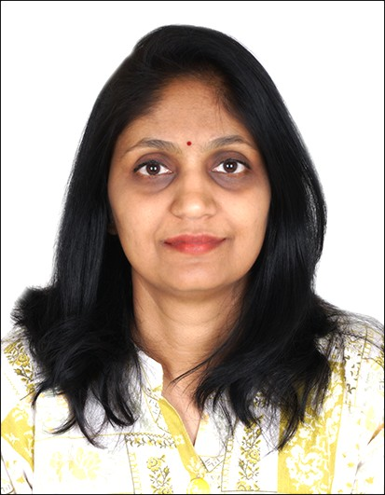

Message from the Dean

Dear Students, Parents, and Patients,
Our institution is committed to excellence in Ayurvedic education, ethical clinical practice, and compassionate healthcare. We strive to nurture competent professionals, provide a supportive learning environment, and deliver patient-centered care rooted in classical Ayurveda and modern quality standards. Your trust and participation inspire us to serve society with responsibility, integrity, and dedication.
ABOUT DEAN
Name: Dr. Jyoti Jagtap
Designation: Dean
Qualification: MD (Kayachikitsa)
Experience: 17+ Years
Email: vdjyotijagtap@gmail.com
Mobile: 9769132371
Date of Birth : 11June 1982
Teacher code : AYKC00644
Registration Number: I-47420 A

Educational Qualifications
Degree | Specialization | University | Year
BAMS | Ayurveda | MUHS | 2004
MD | Kayachikitsa | Nagpur University | 2008
Certificate | Yoga Teacher Training | AYURYOG | 2016
Diploma | Dietetics & Nutrition | NHCA Singapore | 2023
Certificate | Digital Health Foundation Course | MUHS | 2025
Certificate | Certificate course in Digital Health | MUHS | 2026

Academic Leadership & Governance
Role | Details
Principal / Dean (Academics) | Academic planning, monitoring & compliance
NCISM Visitor | 2022, 2023, 2024, 2025
Committee Head | NAAC & NABH Accreditation
UG Academic Coordinator | Curriculum execution & monitoring

Research & Publications Summary
Category | Details
Research Publications | 20
Books Published | 3
National Conferences | 14
International Conferences | 7

Books Published
Sr No | Title | Year | ISBN
1 | Vyaadhisapeksha Ahar | 2022 | Yes
2 | Anatomy Simplified: Sharir Rachana and Rapid Revision | 2025 | Yes
3 | Ahar-Veda | 2026 | Yes

Faculty Development Programs
Program | Year
Research Methodology – Basic | 2013, 2015
Research Methodology – Advanced | 2021
Medical Education Technology – Basic | 2015, 2021
ROTP – Sawantwadi | 2010
ROTP – DY Patil, Pune | 2016
TTT – CCIM | 2018

Extension & Outreach Activities
Activity | Details
Guest Lectures | Ayurvedic Diet, Pregnancy Diet, Diet in Fever
Public Awareness | Aahar & Yoga – Online and Offline
Community Work | Aarogya Bharati
Professional Membership | Ayurveda Vyaspeeth

Areas of Specialization
Academic & Research Interests | PCOS, IBS, Allergy Disorders
Ayurveda Nutrition & Dietetics | Neuromuscular Disorders
Preventive & Lifestyle Medicine | Digital Health in Ayurveda Education

